Cabinet Projection
# Source: AI Source: Provided by: [Data Path: Persons Table -> ID Column: 1, Name_En Column: Motasem Essam] -> From: [ChatGPT] on [7/25/2026]
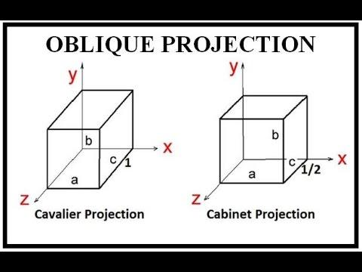
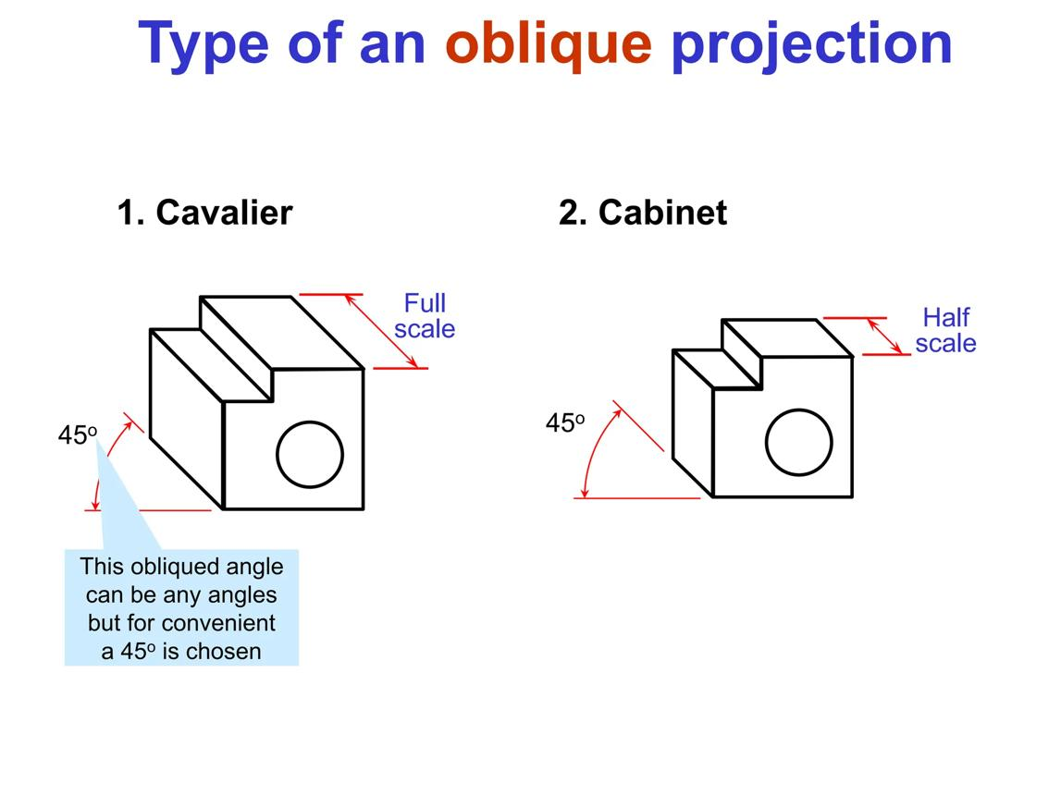
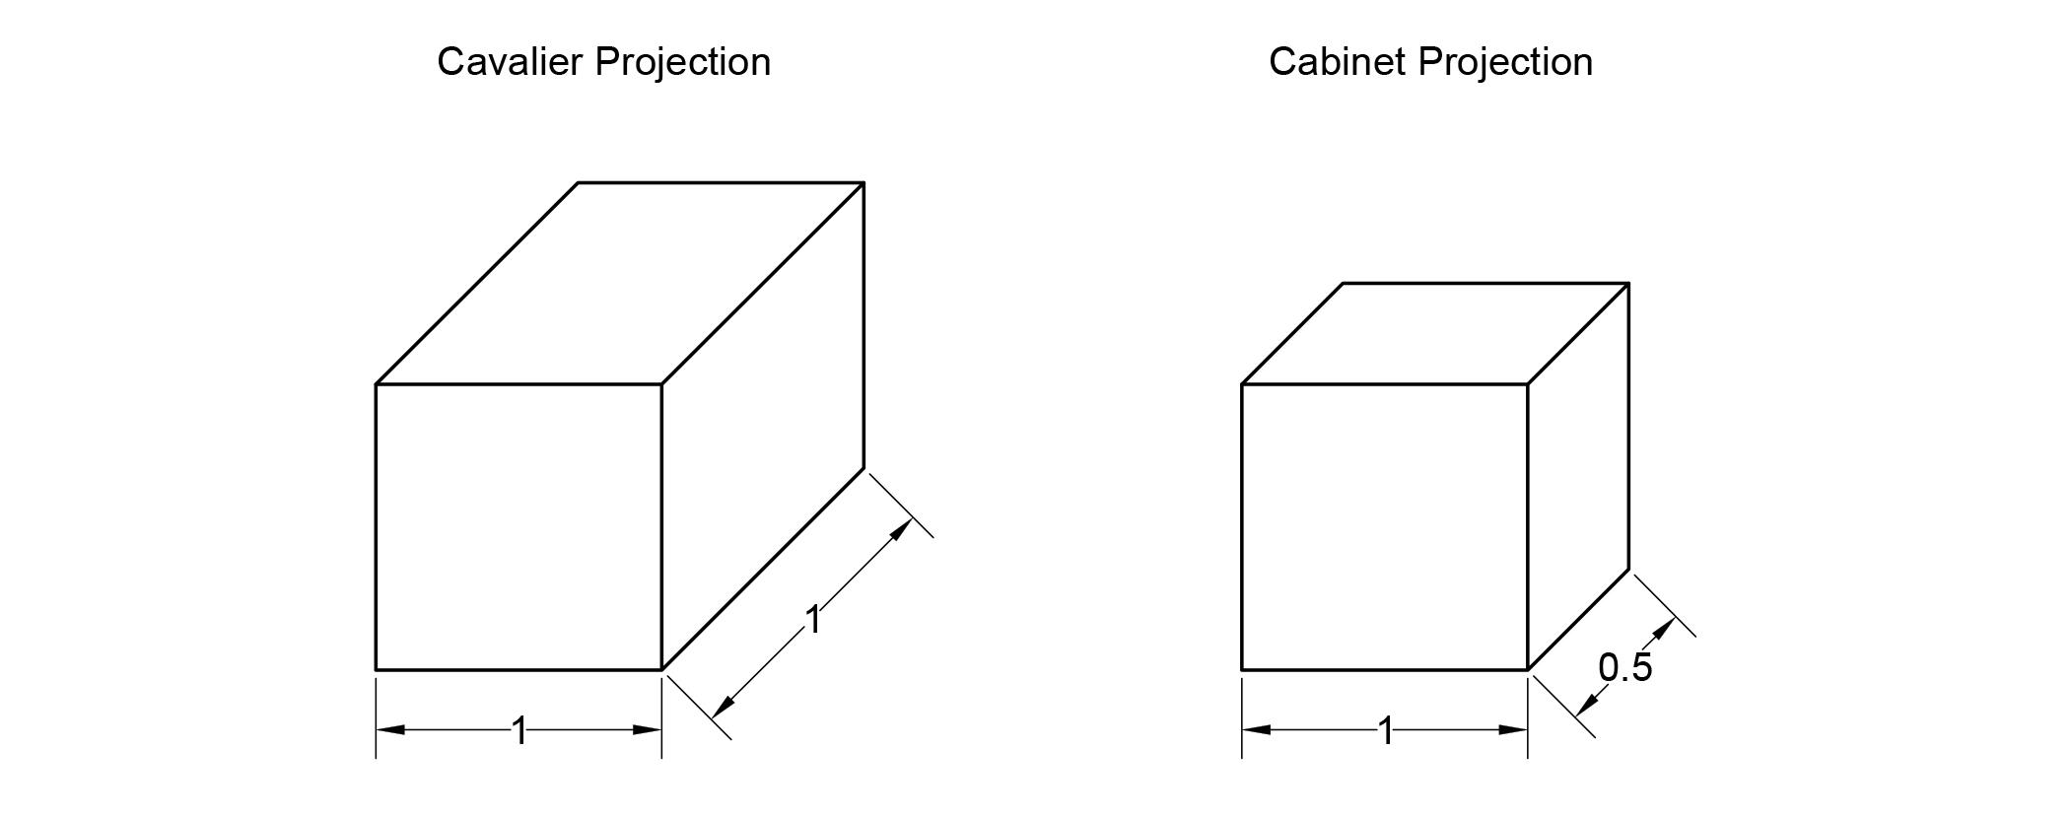
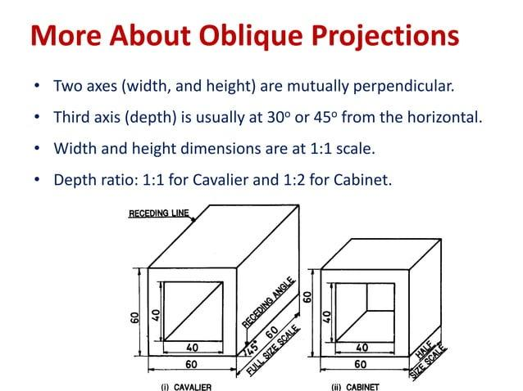
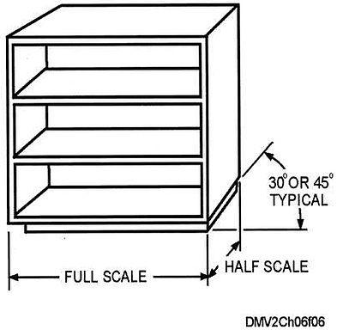

Definition
# Source: AI Source: Provided by: [Data Path: Persons Table -> ID Column: 1, Name_En Column: Motasem Essam] -> From: [ChatGPT] on [7/25/2026]
Cabinet Projection is a type of oblique parallel projection in which a three-dimensional object is projected onto a two-dimensional plane using parallel projection lines, while the depth dimension is usually drawn at half of its actual length.
The main idea is:
$$\boxed{\text{Drawn depth}=\frac{1}{2}\text{ Actual depth}}$$
This reduction makes the object appear more natural than in Cavalier projection.

Purpose
# Source: AI Source: Provided by: [Data Path: Persons Table -> ID Column: 1, Name_En Column: Motasem Essam] -> From: [ChatGPT] on [7/25/2026]
Cabinet projection is used to:
- Represent 3D objects on 2D surfaces.
- Show the front face clearly.
- Represent depth without perspective.
- Reduce the visual distortion caused by full-depth projection.
- Create technical illustrations.
- Represent furniture, mechanical parts, and objects.
- Produce simple 3D diagrams.

Basic Configuration
# Source: AI Source: Provided by: [Data Path: Persons Table -> ID Column: 1, Name_En Column: Motasem Essam] -> From: [ChatGPT] on [7/25/2026]
Consider a rectangular box with front vertices:
$$A, B, C, D$$
and corresponding back vertices:
$$A^{'}, B^{'}, C^{'}, D^{'}$$
The depth lines satisfy:
$$AA^{'}∥BB^{'}∥CC^{'}∥DD^{'}$$
However, unlike Cavalier projection, the depth edges are shortened.
If the actual depth is $D$, then:
$\boxed{D^{'}=\frac{D}{2}}$
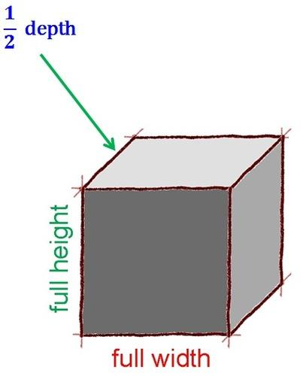
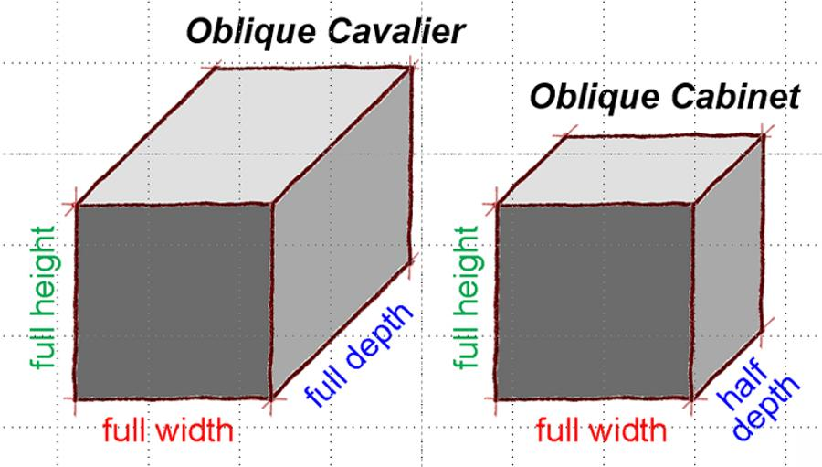
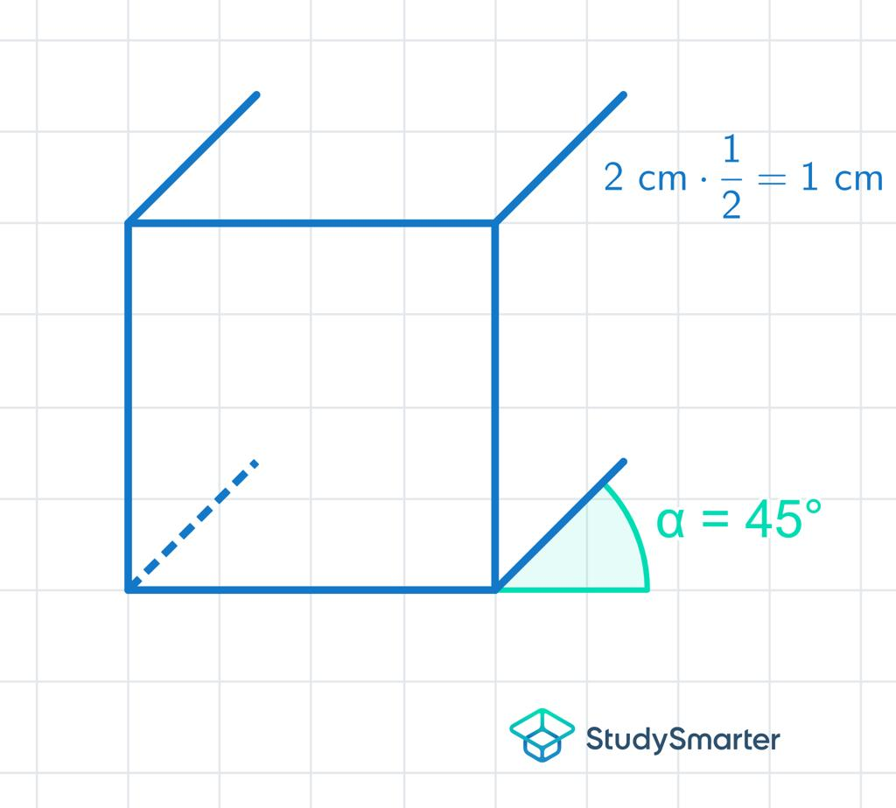
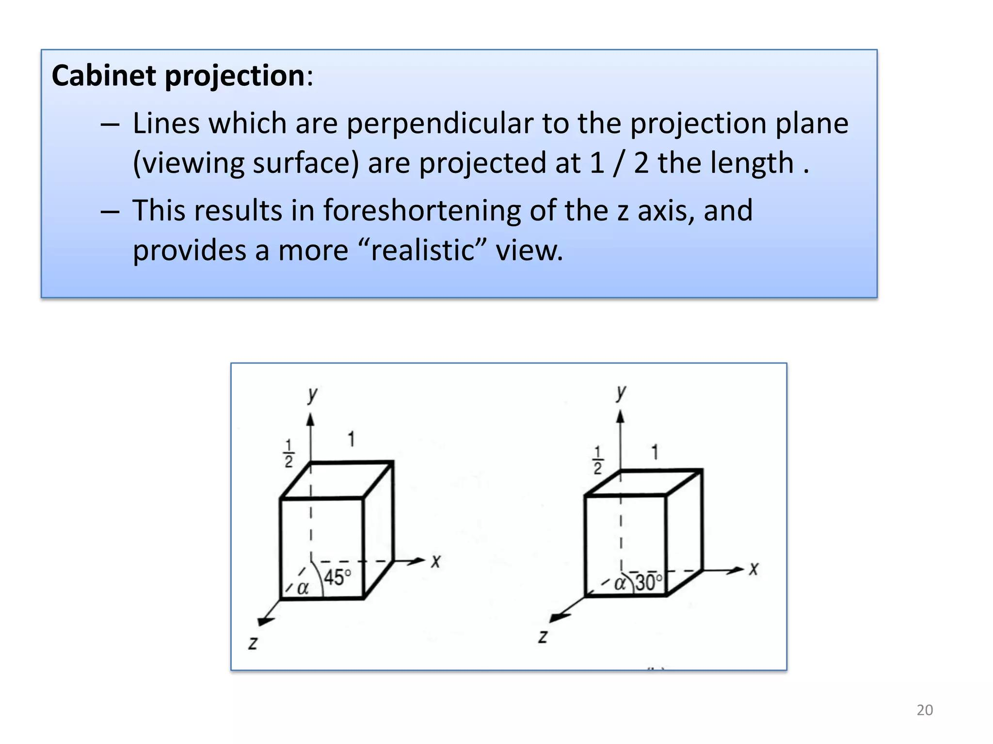
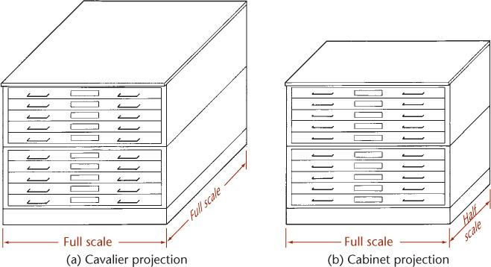

Fundamental Elements

1. Projection Plane
# Source: AI Source: Provided by: [Data Path: Persons Table -> ID Column: 1, Name_En Column: Motasem Essam] -> From: [ChatGPT] on [7/25/2026]
The two-dimensional plane onto which the object is projected.
$$Π$$

2. Original Object
# Source: AI Source: Provided by: [Data Path: Persons Table -> ID Column: 1, Name_En Column: Motasem Essam] -> From: [ChatGPT] on [7/25/2026]
The three-dimensional object being represented.
Examples include:
- Cube
- Rectangular prism
- Cylinder
- Furniture
- Mechanical component

3. Projection Direction
# Source: AI Source: Provided by: [Data Path: Persons Table -> ID Column: 1, Name_En Column: Motasem Essam] -> From: [ChatGPT] on [7/25/2026]
The direction in which the projection lines travel:
$$d$$
For Cabinet projection:
$$d⟂̸Π$$
Therefore, it is an oblique projection.

4. Projection Lines
# Source: AI Source: Provided by: [Data Path: Persons Table -> ID Column: 1, Name_En Column: Motasem Essam] -> From: [ChatGPT] on [7/25/2026]
All projection lines are parallel:
$$AA^{'}∥BB^{'}∥CC^{'}$$

5. Projected Object
# Source: AI Source: Provided by: [Data Path: Persons Table -> ID Column: 1, Name_En Column: Motasem Essam] -> From: [ChatGPT] on [7/25/2026]
The resulting two-dimensional representation.

Main Characteristics
# Source: AI Source: Provided by: [Data Path: Persons Table -> ID Column: 1, Name_En Column: Motasem Essam] -> From: [ChatGPT] on [7/25/2026]
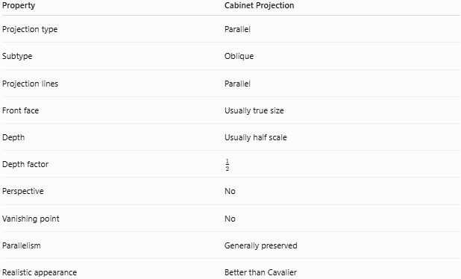
Property | Cabinet Projection
Projection type | Parallel
Subtype | Oblique
Projection lines | Parallel
Front face | Usually true size
Depth | Usually half scale
Depth factor | $$\frac{1}{2}$$
Perspective | No
Vanishing point | No
Parallelism | Generally preserved
Realistic appearance | Better than Cavalier

Depth Dimension
# Source: AI Source: Provided by: [Data Path: Persons Table -> ID Column: 1, Name_En Column: Motasem Essam] -> From: [ChatGPT] on [7/25/2026]
The most important characteristic of Cabinet projection is the reduction of depth.
If the actual depth is:
$$D=10\text{ cm}$$
then the commonly used Cabinet representation is:
$D^{'}=\frac{10}{2}$ $\boxed{D^{'}=5\text{ cm}}$
Therefore:
$$\boxed{\text{Cabinet depth}=\frac{1}{2}\text{ actual depth}}$$
The reduction helps prevent the object from appearing excessively deep.

Projection Angle
# Source: AI Source: Provided by: [Data Path: Persons Table -> ID Column: 1, Name_En Column: Motasem Essam] -> From: [ChatGPT] on [7/25/2026]
Cabinet projection commonly uses an oblique direction such as:
$${45}^{∘}$$
for the receding/depth lines.
However, ${45}^{∘}$ is a common convention, not the fundamental definition.
The essential characteristics are:
- Projection lines are parallel.
- The projection is oblique.
- Depth is commonly reduced to one-half.

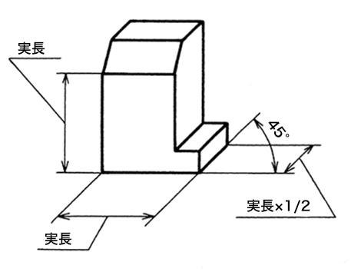
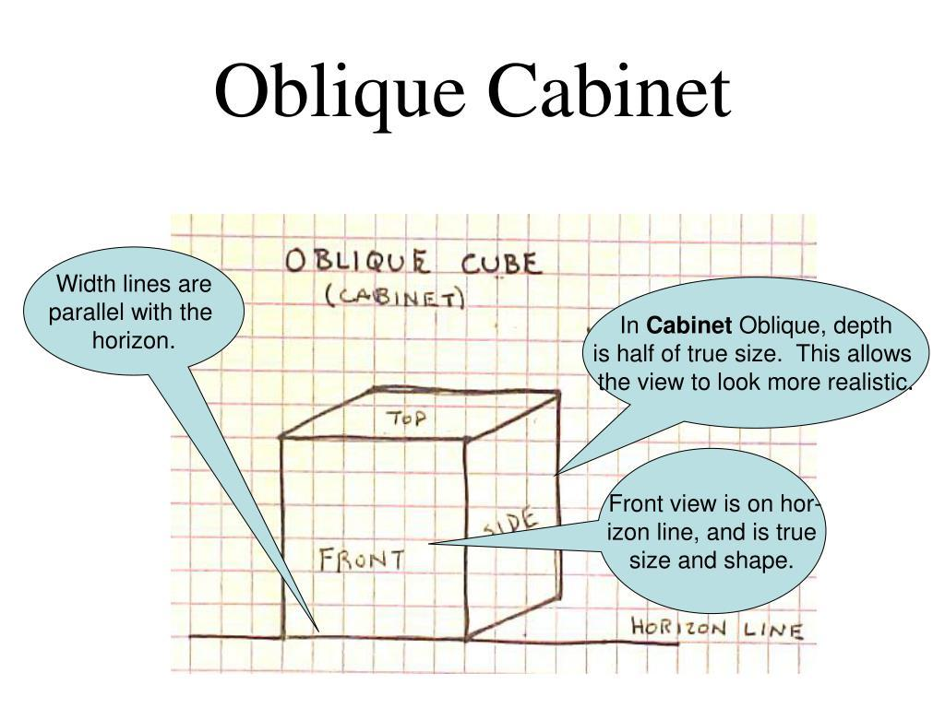
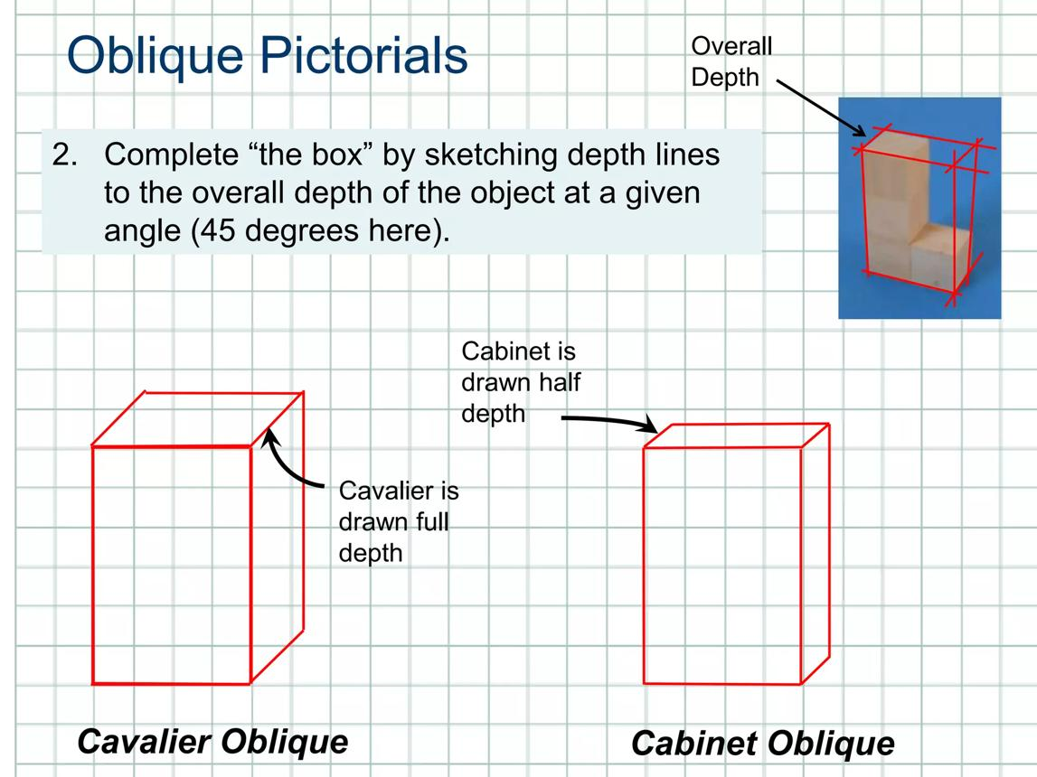
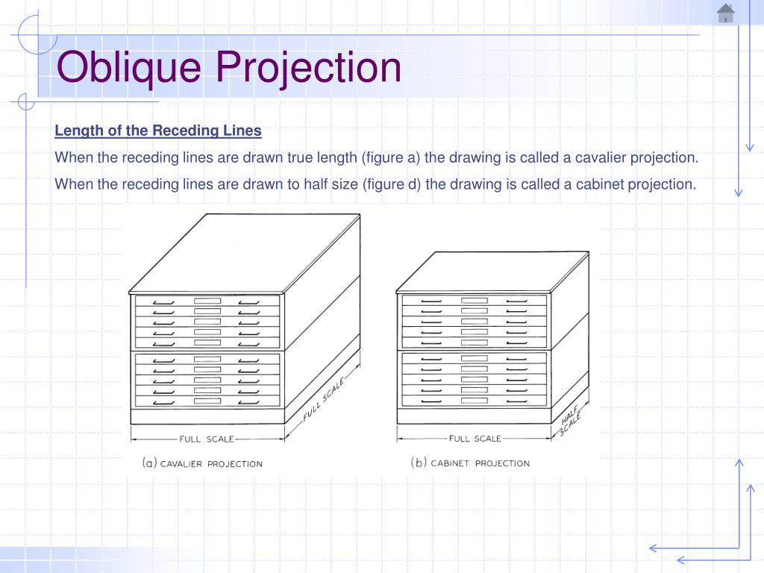

Mathematical Representation
# Source: AI Source: Provided by: [Data Path: Persons Table -> ID Column: 1, Name_En Column: Motasem Essam] -> From: [ChatGPT] on [7/25/2026]
A general parallel projection can be represented by:
$$P^{'}=P+td$$
where:
- $P$ = original point
- $P^{'}$ = projected point
- $d$ = projection direction
- $t$ = scalar
For Cabinet projection, the drawing convention applies a depth reduction factor:
$$k=\frac{1}{2}$$
Thus, for a depth dimension $D$:
$$\boxed{D^{'}=kD}$$
and for the standard Cabinet convention:
$$\boxed{D^{'}=\frac{1}{2}D}$$

Example 1: Rectangular Box
# Source: AI Source: Provided by: [Data Path: Persons Table -> ID Column: 1, Name_En Column: Motasem Essam] -> From: [ChatGPT] on [7/25/2026]
Suppose a box has:
$W=8$ $H=5$ $D=6$
In Cabinet projection:
Width
$$W^{'}=8$$
Height
$$H^{'}=5$$
Depth
$$D^{'}=\frac{1}{2}(6)=3$$
Therefore:
$$\boxed{W^{'}=8, H^{'}=5, D^{'}=3}$$
The front face retains its dimensions while the depth is reduced.

Example 2: Depth Edge
# Source: AI Source: Provided by: [Data Path: Persons Table -> ID Column: 1, Name_En Column: Motasem Essam] -> From: [ChatGPT] on [7/25/2026]
Suppose an actual depth edge has length:
$$AB=12\text{ cm}$$
Using the standard Cabinet depth scale:
$A^{'}B^{'}=\frac{1}{2}(12)$ $\boxed{A^{'}B^{'}=6\text{ cm}}$
So the depth is represented at half scale.

Example 3: Comparing with Cavalier Projection
# Source: AI Source: Provided by: [Data Path: Persons Table -> ID Column: 1, Name_En Column: Motasem Essam] -> From: [ChatGPT] on [7/25/2026]
Suppose the actual depth is:
$$D=8\text{ cm}$$
Cavalier Projection
$$D^{'}=8\text{ cm}$$
Cabinet Projection
$$D^{'}=\frac{1}{2}(8)=4\text{ cm}$$
Therefore:
$\boxed{\text{Cavalier}=8\text{ cm}}$ $\boxed{\text{Cabinet}=4\text{ cm}}$

How to Construct a Cabinet Projection

Step 1 — Draw the front face
# Source: AI Source: Provided by: [Data Path: Persons Table -> ID Column: 1, Name_En Column: Motasem Essam] -> From: [ChatGPT] on [7/25/2026]
Draw the front face using its actual dimensions.
For example:
$$6×4$$

Step 2 — Choose the depth direction
# Source: AI Source: Provided by: [Data Path: Persons Table -> ID Column: 1, Name_En Column: Motasem Essam] -> From: [ChatGPT] on [7/25/2026]
Choose an oblique direction, commonly:
$${45}^{∘}$$

Step 3 — Calculate the represented depth
# Source: AI Source: Provided by: [Data Path: Persons Table -> ID Column: 1, Name_En Column: Motasem Essam] -> From: [ChatGPT] on [7/25/2026]
If the actual depth is:
$$D=6$$
then:
$$D^{'}=\frac{6}{2}=3$$

Step 4 — Draw the depth lines
# Source: AI Source: Provided by: [Data Path: Persons Table -> ID Column: 1, Name_En Column: Motasem Essam] -> From: [ChatGPT] on [7/25/2026]
From the appropriate vertices, draw parallel lines in the selected direction.
Each depth line has the reduced length:
$$D^{'}=3$$

Step 5 — Connect the corresponding vertices
# Source: AI Source: Provided by: [Data Path: Persons Table -> ID Column: 1, Name_En Column: Motasem Essam] -> From: [ChatGPT] on [7/25/2026]
Connect the endpoints to complete the 3D representation.
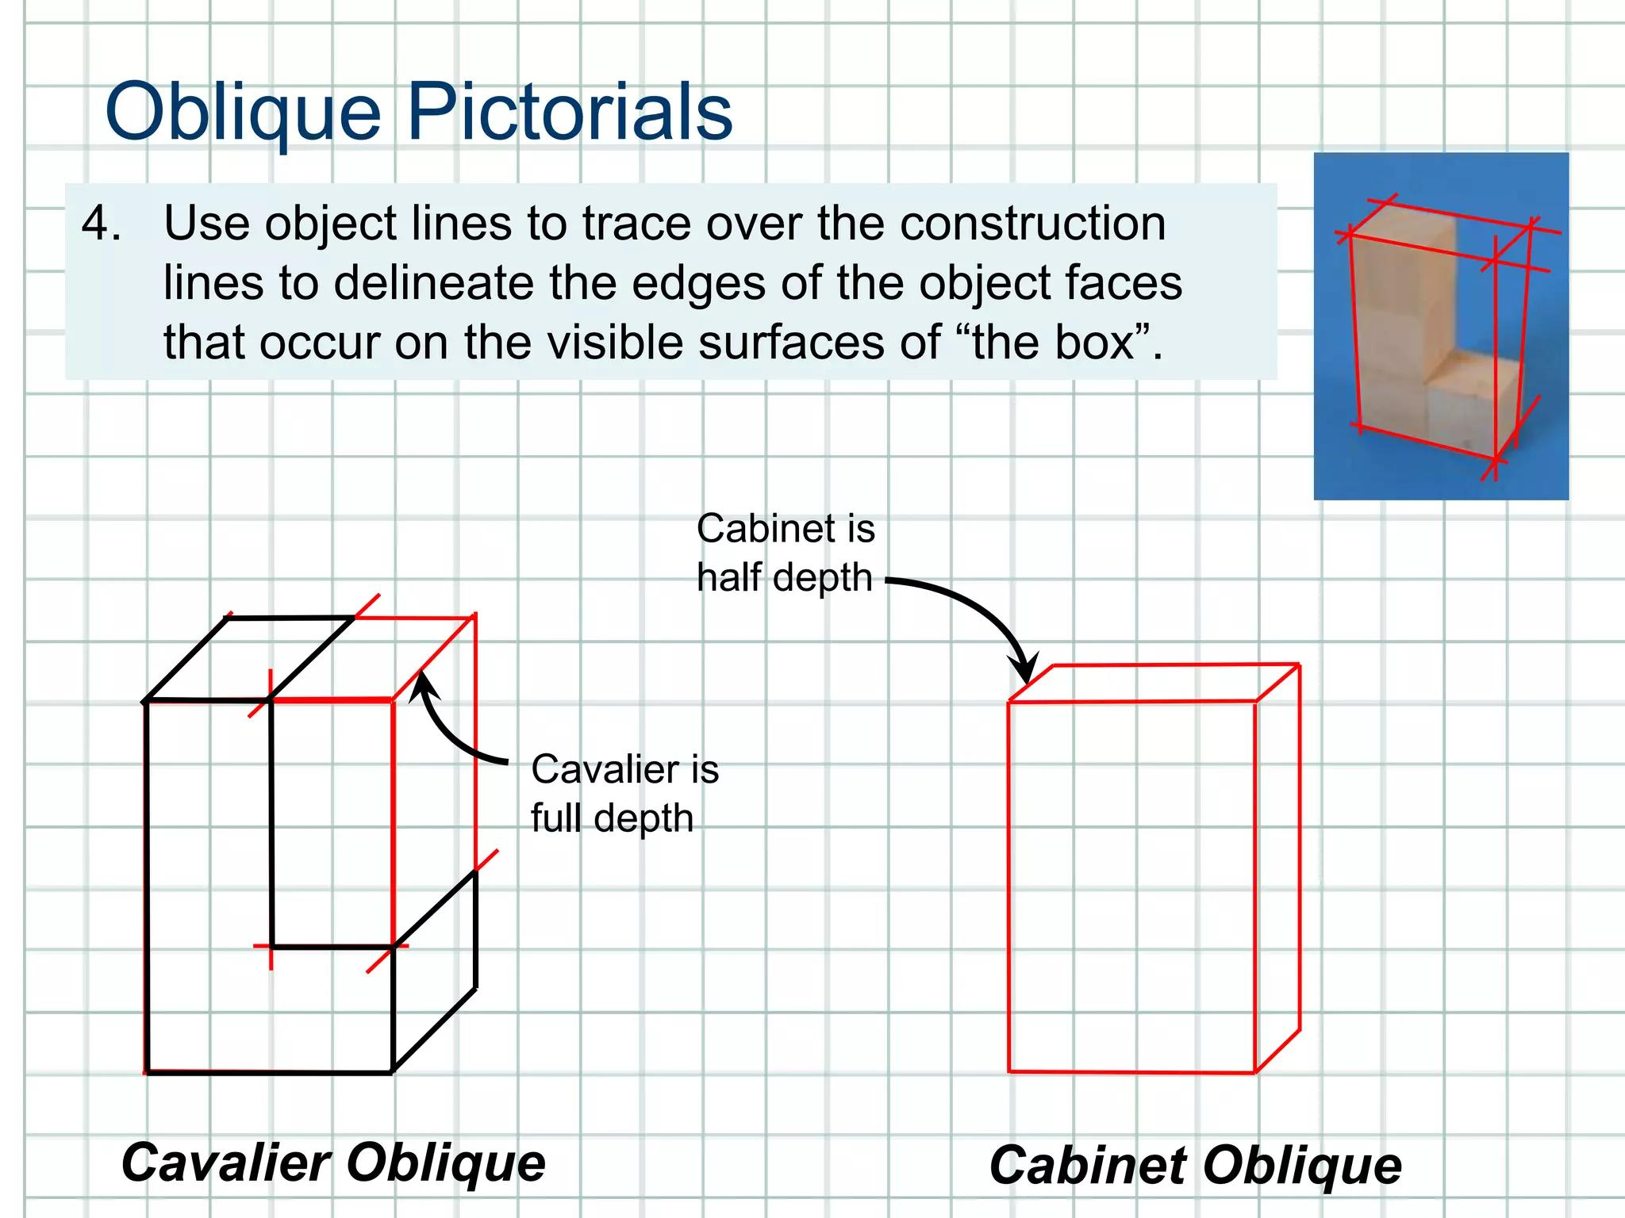
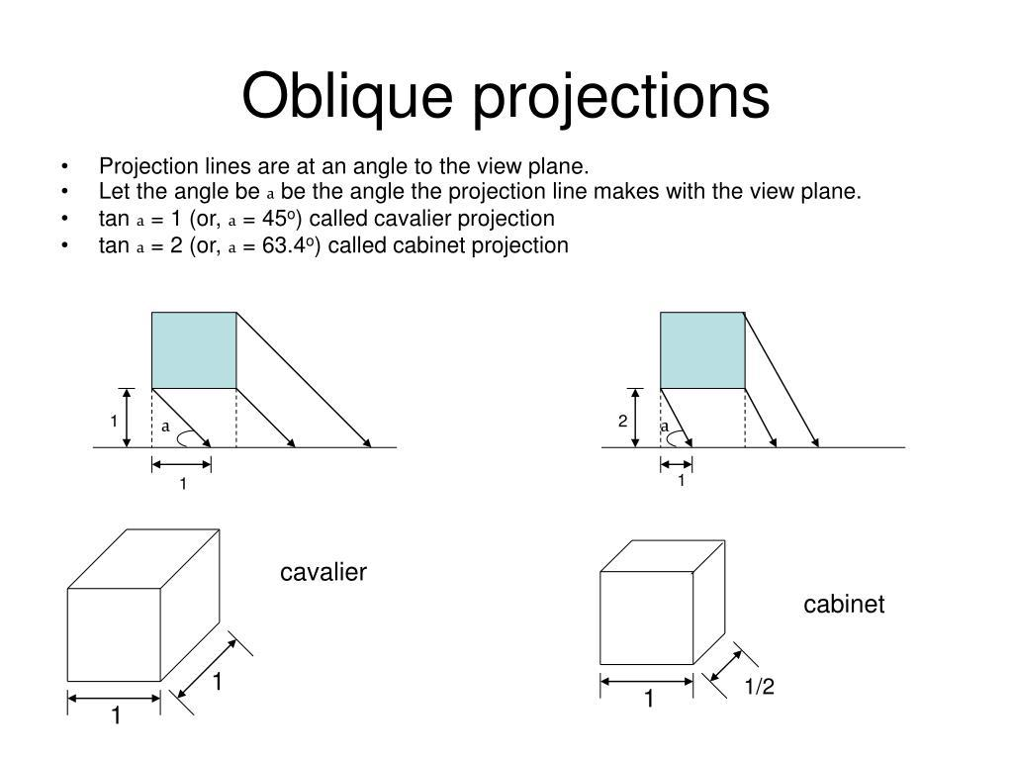
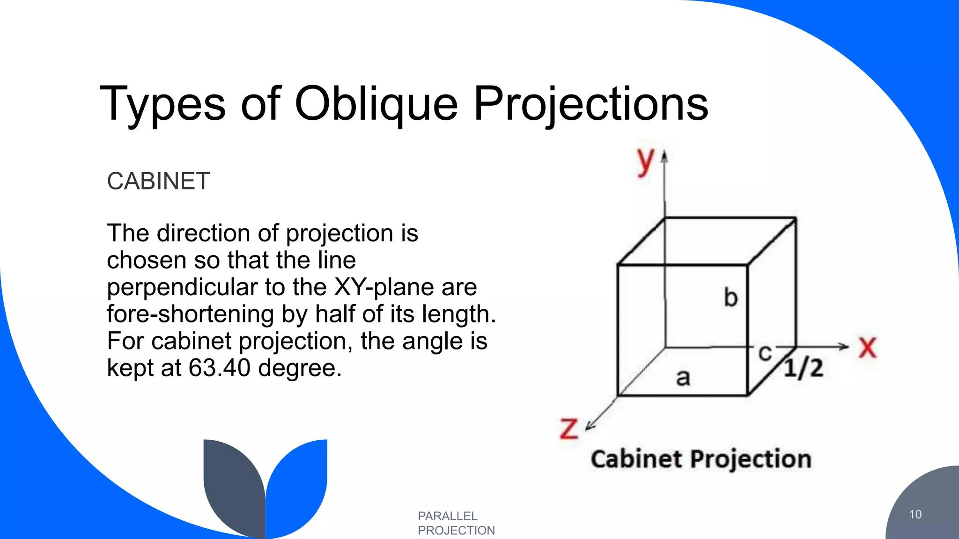

Cabinet Projection of a Cube
# Source: AI Source: Provided by: [Data Path: Persons Table -> ID Column: 1, Name_En Column: Motasem Essam] -> From: [ChatGPT] on [7/25/2026]
Consider a cube with side length:
$$a$$
The front face is drawn as:
$$a×a$$
The actual depth is also:
$$a$$
But the Cabinet representation uses:
$$D^{'}=\frac{a}{2}$$
Therefore:
$\boxed{W^{'}=a}$ $\boxed{H^{'}=a}$ $\boxed{D^{'}=\frac{a}{2}}$
For example, for a cube with:
$$a=10\text{ cm}$$
the drawing uses:
$W^{'}=10\text{ cm}$ $H^{'}=10\text{ cm}$ $D^{'}=5\text{ cm}$

Properties

1. Projection lines are parallel
# Source: AI Source: Provided by: [Data Path: Persons Table -> ID Column: 1, Name_En Column: Motasem Essam] -> From: [ChatGPT] on [7/25/2026]
$$AA^{'}∥BB^{'}∥CC^{'}$$

2. Depth is reduced
# Source: AI Source: Provided by: [Data Path: Persons Table -> ID Column: 1, Name_En Column: Motasem Essam] -> From: [ChatGPT] on [7/25/2026]
Under the standard convention:
$$D^{'}=\frac{D}{2}$$

3. Front face can retain its true dimensions
# Source: AI Source: Provided by: [Data Path: Persons Table -> ID Column: 1, Name_En Column: Motasem Essam] -> From: [ChatGPT] on [7/25/2026]
The front face is normally drawn at full scale.

4. No vanishing point
# Source: AI Source: Provided by: [Data Path: Persons Table -> ID Column: 1, Name_En Column: Motasem Essam] -> From: [ChatGPT] on [7/25/2026]
The projection lines do not converge.

5. Parallelism is generally preserved
# Source: AI Source: Provided by: [Data Path: Persons Table -> ID Column: 1, Name_En Column: Motasem Essam] -> From: [ChatGPT] on [7/25/2026]
Parallel lines remain parallel in the projection.

6. Angles are not generally preserved
# Source: AI Source: Provided by: [Data Path: Persons Table -> ID Column: 1, Name_En Column: Motasem Essam] -> From: [ChatGPT] on [7/25/2026]
Oblique depth lines can change the apparent angles.

7. Depth appears less exaggerated
# Source: AI Source: Provided by: [Data Path: Persons Table -> ID Column: 1, Name_En Column: Motasem Essam] -> From: [ChatGPT] on [7/25/2026]
Reducing depth makes Cabinet projection visually more natural than Cavalier projection.

Cabinet Projection vs Cavalier Projection
# Source: AI Source: Provided by: [Data Path: Persons Table -> ID Column: 1, Name_En Column: Motasem Essam] -> From: [ChatGPT] on [7/25/2026]

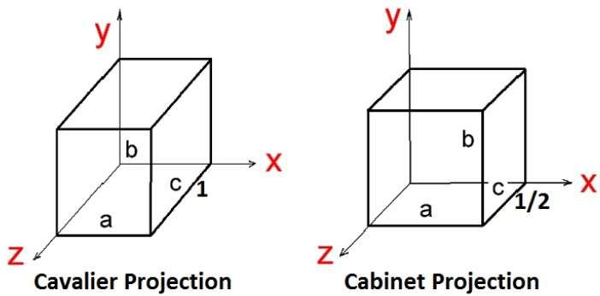
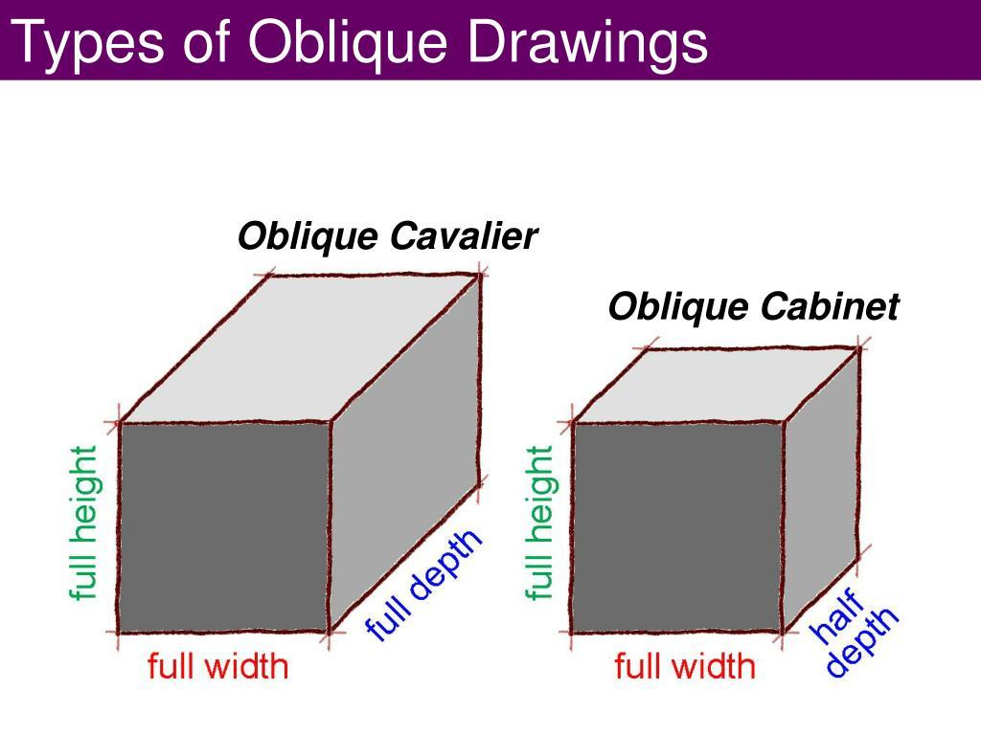
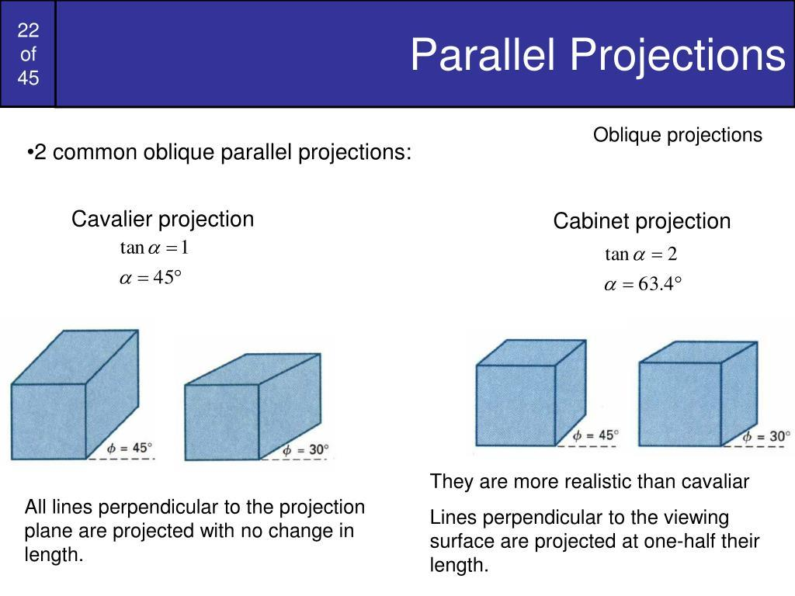
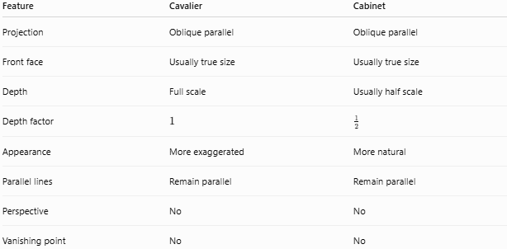
Feature | Cavalier | Cabinet
Projection | Oblique parallel | Oblique parallel
Front face | Usually true size | Usually true size
Depth | Full scale | Usually half scale
Depth factor | $$1$$ | $$\frac{1}{2}$$
Appearance | More exaggerated | More natural
Parallel lines | Remain parallel | Remain parallel
Perspective | No | No
Vanishing point | No | No

Most important distinction
$\boxed{\text{Cavalier: }D^{'}=D}$ $\boxed{\text{Cabinet: }D^{'}=\frac{D}{2}}$

Cabinet Projection vs Orthogonal Projection
# Source: AI Source: Provided by: [Data Path: Persons Table -> ID Column: 1, Name_En Column: Motasem Essam] -> From: [ChatGPT] on [7/25/2026]
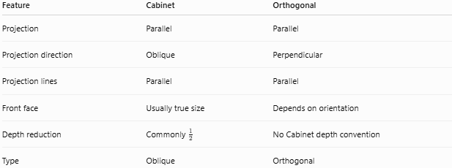
Feature | Cabinet | Orthogonal
Projection | Parallel | Parallel
Projection direction | Oblique | Perpendicular
Projection lines | Parallel | Parallel
Front face | Usually true size | Depends on orientation
Depth reduction | Commonly $\frac{1}{2}$ | No Cabinet depth convention
Type | Oblique | Orthogonal
The fundamental distinction is:
$$\boxed{\text{Cabinet: }d⟂̸Π}$$
while:
$$\boxed{\text{Orthogonal: }d⟂Π}$$

Cabinet Projection vs Perspective Projection
# Source: AI Source: Provided by: [Data Path: Persons Table -> ID Column: 1, Name_En Column: Motasem Essam] -> From: [ChatGPT] on [7/25/2026]
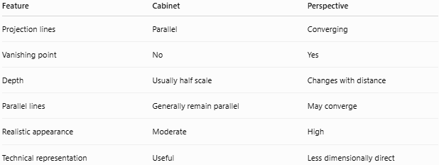
Feature | Cabinet | Perspective
Projection lines | Parallel | Converging
Vanishing point | No | Yes
Depth | Usually half scale | Changes with distance
Parallel lines | Generally remain parallel | May converge
Realistic appearance | Moderate | High
Technical representation | Useful | Less dimensionally direct

Relationship to Oblique Projection
# Source: AI Source: Provided by: [Data Path: Persons Table -> ID Column: 1, Name_En Column: Motasem Essam] -> From: [ChatGPT] on [7/25/2026]
Cabinet projection belongs to the following hierarchy:
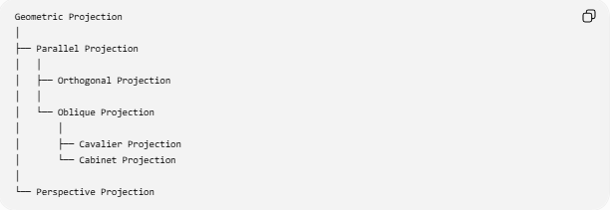
Geometric Projection
│
├── Parallel Projection
│ │
│ ├── Orthogonal Projection
│ │
│ └── Oblique Projection
│ │
│ ├── Cavalier Projection
│ └── Cabinet Projection
│
└── Perspective Projection
Therefore:
$$\boxed{\text{Cabinet Projection}⊂\text{Oblique Projection}⊂\text{Parallel Projection}}$$

Applications
# Source: AI Source: Provided by: [Data Path: Persons Table -> ID Column: 1, Name_En Column: Motasem Essam] -> From: [ChatGPT] on [7/25/2026]
Cabinet projection can be used for:
- Technical illustrations
- Engineering diagrams
- Mechanical drawings
- Furniture illustrations
- Architectural sketches
- Product diagrams
- Geometry textbooks
- Educational diagrams
- Representing boxes and rectangular objects
- Some CAD and drafting applications

Advantages
# Source: AI Source: Provided by: [Data Path: Persons Table -> ID Column: 1, Name_En Column: Motasem Essam] -> From: [ChatGPT] on [7/25/2026]
- Simple to construct.
- Easy to interpret.
- Front face can retain true dimensions.
- Reduces excessive depth distortion.
- Preserves parallel relationships.
- Does not require vanishing points.
- More visually natural than Cavalier projection.
- Useful for technical illustrations.

Limitations
# Source: AI Source: Provided by: [Data Path: Persons Table -> ID Column: 1, Name_En Column: Motasem Essam] -> From: [ChatGPT] on [7/25/2026]
- Still does not provide realistic perspective.
- Depth is artificially reduced.
- Angles are not generally preserved.
- Not suitable when true perspective appearance is required.
- The standard $\frac{1}{2}$ depth factor is a convention rather than a universal physical rule.
- Objects can still appear somewhat distorted.

Special Cases

Standard Cabinet Projection
# Source: AI Source: Provided by: [Data Path: Persons Table -> ID Column: 1, Name_En Column: Motasem Essam] -> From: [ChatGPT] on [7/25/2026]
The most common convention is:
$$\boxed{k=\frac{1}{2}}$$
so:
$$\boxed{D^{'}=\frac{D}{2}}$$

Different Depth Scale
# Source: AI Source: Provided by: [Data Path: Persons Table -> ID Column: 1, Name_En Column: Motasem Essam] -> From: [ChatGPT] on [7/25/2026]
In some applications, a different depth scale may be chosen:
$$D^{'}=kD$$
where $k$ is a selected scale factor.
For example:
$$k=\frac{1}{2}$$
is the standard Cabinet convention.

If the Projection Direction Becomes Perpendicular
# Source: AI Source: Provided by: [Data Path: Persons Table -> ID Column: 1, Name_En Column: Motasem Essam] -> From: [ChatGPT] on [7/25/2026]
If:
$$d⟂Π$$
the projection becomes orthogonal projection, rather than oblique Cabinet projection.

Key Points
# Source: AI Source: Provided by: [Data Path: Persons Table -> ID Column: 1, Name_En Column: Motasem Essam] -> From: [ChatGPT] on [7/25/2026]
- Cabinet Projection is an oblique parallel projection.
- Its projection lines are parallel.
- The front face is normally drawn at its true size.
- Depth is usually reduced to one-half.
- A ${45}^{∘}$ receding direction is commonly used.
- It has no vanishing point.
- It looks more natural than Cavalier projection.
- It is useful for technical and educational illustrations.
- Its defining practical convention is:
$$\boxed{\text{Drawn depth}=\frac{1}{2}\text{ Actual depth}}$$

Conclusion
# Source: AI Source: Provided by: [Data Path: Persons Table -> ID Column: 1, Name_En Column: Motasem Essam] -> From: [ChatGPT] on [7/25/2026]
Cabinet Projection represents a 3D object on a 2D plane using parallel oblique projection lines, while reducing the depth dimension—commonly to one-half of its actual length. This reduction produces a less exaggerated and more visually balanced representation than Cavalier projection, while retaining the simplicity and parallelism of parallel projection.

